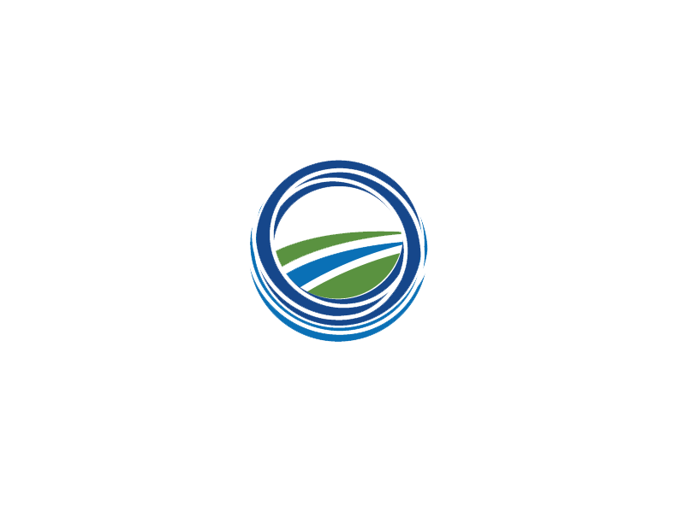
Environmental Federation of Oklahoma
Membership Application
MEMBER INFORMATION |  |  | MEMBERSHUP DUES
Instructions: Complete areas in the white areas only. |  |  | ☐ | Company (3 or more facilities) |  |  |  |  | $6000
Company Name |  |  | ☐ | Company (2 facilities) |  |  |  |  | $5000
 |  |  | ☐ | Company (1 facility) |  |  |  |  | $2500
Type of Company (Products manufactured, services provided, etc.) |  |  | ☐ | Company – Oil & Gas E&P Only |  |  |  |  | $1200
 |  |  | ☐ | Associate |  |  |  |  | $600
Oklahoma Location(s): |  |  | ☐ | Affiliate |  |  |  |  | $500
 |  |  | ☐ | Appendix Affiliate |  |  |  |  | $500
Address | City | State | Call to discuss the appropriate membership
 |  |  | level for your company.
Zip Code | Phone Number |  | PAYMENT OPTIONS
 |  |  | A form of payment MUST be indicated below.
Website |  |  | ☐ | Check enclosed – Check No:
 |  |  | (payable in US funds to Environmental Federation of Oklahoma)
 |  |  | ☐ | Bill my Credit Card (EFO will invoice electronically)
CONTACT INFORMATION |  |  | ☐ | P.O. Number
Primary Contact Name (for benefit fulfillment and billing purposes) |  |  | (requires documentation of purchase order attached)
Name | Title |  | Membership benefits begin once invoice is paid in full.
 |  |  | REGULATORY INTERESTS
Office Phone | Mobile |  | Environmental Permits
 |  |  | Air
Email Address |  |  | ☐ | Major Air |  | ☐ | Minor Air - Multiple
 |  |  | ☐ | GHG |  | ☐ | Minor Air - single
Secondary Contact Name |  |  | ☐ | RMP |  | ☐ | PBR Permits
Name | Title
 |  |  | Water
Office Phone | Mobile Phone |  | ☐ | NPDES |  | ☐ | UIC
 |  |  | ☐ | SWPPP |  | ☐ | Other – List below
Email address
 |  |  | Solid & Hazardous Waste
Additional Name 1 |  |  | ☐ | Solid Waste |  | ☐ | Hazardous Waste
Nane | Title |  | ☐ | TSDF |  | ☐ | Other – List below
Office Phone | Mobile Phone |  | Other Regulatory Interests
 |  |  | ☐ | Wildlife |  | ☐ | Health & Safety
Email address |  |  | ☐ | Corporation Commission
 |  |  | EFO Committee Interests
Additional Name 2 |  |  | ☐ | Legislative |  | ☐ | Activities
Nane | Title |  | PAYMENT INFORMATION
 |  |  | - Email application to jody@envirofdok.org for electronic
Office Phone | Mobile Phone |  | payment or PO information.
 |  |  | - If paying by check, submit with application.
Email address |  |  | - Submit company logo with application.
 |  |  | Environmental Federation of Oklahoma
If there are more than 4 EHS, Legal, or Plant Management personnel names, please attach list for with the requested information above to application. Please email list to jody@envirofdok.org. |  |  | 4 N.E. 10th Street #443
 |  |  | Oklahoma City, OK 73104
 |  |  | 405.509.1135
Note: All applications subject to review and approval. |  |  | Members Get More!
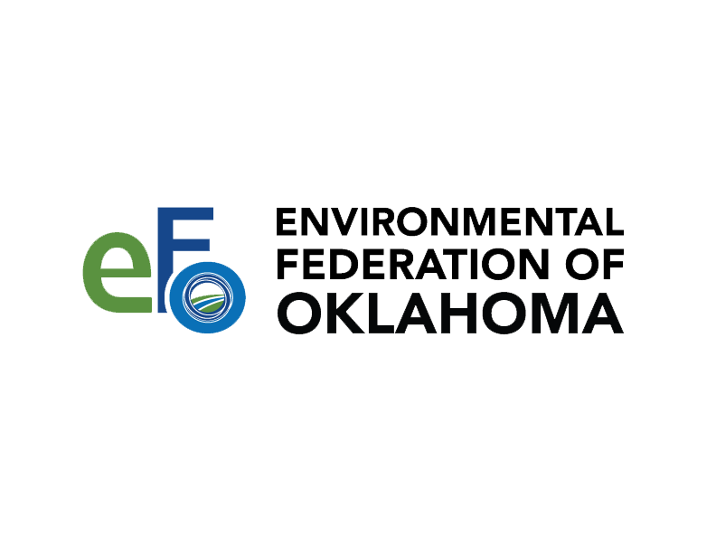

“Working for Oklahoma’s Economic and Environmental Future”
Membership Levels
- Company: Any company doing business in Oklahoma who hold major environmental permits Eligible for Board of Directors
- Associate: Associations and smaller companies doing business in Oklahoma with limited environmental permits. Not eligible for Board of Directors
- Affiliate: Consultants; limited by the number of member companies per EFO By-Laws. Eligible for Board of Directors
- Appendix Affiliate: Consultants exceeding the number allowed by the EFO By-Laws. Not eligible for Board of Directors

Membership Fees
- Company – 3 or more facilities $6000
- Company – 2 facilities $5000
- Company – 1 facility $2500
- Company – O&G E&P only $1200
- Associate $600
- Affiliate $500
- Appendix Affiliate $500
- Student $15

Call to discuss appropriate membership level for your company. All applications subject to review and approval.

For more information contact:
Howard L (Bud) Ground, President
Environmental Federation of Oklahoma
4 N.E. 10th Street #443
Oklahoma City, OK 73104
Office 405.509.1135
bud@envirofdok.org
www.envirofdok.org/membership

Mission Statement
- Actively promoting the development of sound environmental policies and legislation
- Educating and informing EFO members, government officials and the citizens of Oklahoma as to the environmental issues affecting commerce
- Addressing the common environmental concerns of EFO members

Membership Benefits
- Legislative lobbying for Oklahoma businesses with weekly updates on pending legislation and other regulatory news
- Regulatory interface between business and the regulatory agencies
- Outreach to other business interest groups
- Members ONLY twice monthly EFO News Update to keep you current on regulatory news
- Access to Members ONLY part of website
- Reduced rates to attend events
- Dues are typically 50% tax deductible
- Eligible for Frank Condon Environmental Excellence Award for environmental projects

Activities
- Legislative Reception – exclusive for Members ONLY
- EFO Newsreel – co-sponsored with the ODEQ in June annually
- EFO Annual Meeting and Trade Show held annually each fall
- Other technical seminars as regulations are issued or updated

