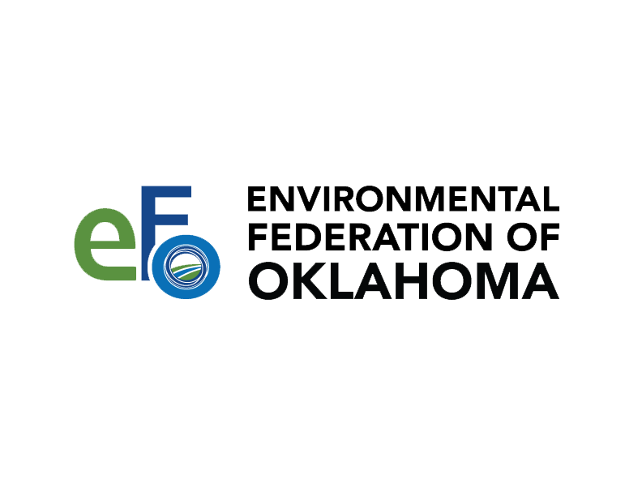

Instructions: The Call for Papers and Speakers application must be received no later than June 30, 2023. Please email your completed form to bud@envirofdok.org and Jennifer.wasinger@freese.com. For additional information, please see the Call for Papers Instructions.

Please complete all the grey areas including the check boxes.

SPEAKER INFORMATION
This section must include the names of all speakers. Please make copy this section in the application as needed.
Full Name
Job Title |  |  |  |  | EFO Member?
Organization |  |  |  |  | ☐ Yes | ☐ No
Address |  | City, State, Zip
Contact Phone |  | Email
Designations
Certifications

PRESENTATION INFORMATION
Title of Presentation
Format | ☐ Individual (1-2 Speakers) |  | ☐ Group/Panel (3 or more Speakers)
Other Presenter Names
Method | ☐ Lecture Presentation | ☐ Case Study |  | ☐ Panel Discussion
Level | ☐ Basic | ☐ Intermediate |  | ☐ Advanced

SUBJECT AREA
Select the most appropriate subject area(s) of the presentation.
☐ Air | ☐ Water | ☐ Solid Waste | ☐ Land Protection
☐ Corporation Commission |  | ☐ Wildlife
☐ Health & Safety | ☐ Other (describe):

PRESENTATION DESCRIPTION
Please provide a short description (50-200 words) of the presentation that includes an overview and what attendees will gain from the presentation.

SHORT BIOGRAPHICAL INFORMATION OF EACH SPEAKER
This section must be completed for each speaker if more than one speaker will be presenting.

Do we have your permission to provide your contact information  (Name, company, email, and phone) to the attendees? | ☐ Yes ☐ No
Do we have your permission to post your presentation slides as a PDF file on the EFO website after the meeting? | ☐ Yes ☐ No

Signature (electronic) |  | Date

