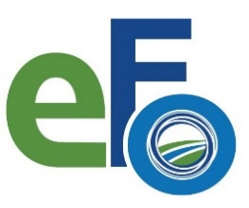
Environmental Federation of Oklahoma
30th EFO Annual Meeting and Trade Show
Sponsor / Exhibitor Information Form
4 NE 10th Street #443, Oklahoma City, OK 73104 Office 405.942.2443 www.envirofdok.org

If you register to Exhibit or be a Sponsor at the 30th Annual EFO Meeting and Trade Show, please complete the information below and return by no later than August 13, 2021.

Please email 1) the completed copy of this form and 2) a current copy of your company’s current logo (the size must have sufficient pixels to be sized up for poster) to: jody@envirofdok.org.

Company Name:

Trade Show Contact(s):

Company Contact(s):

Address:

City:

State:

Zip Code:

Telephone:

FAX:

E-mail:

Website:

Brief Summary of Services or Products – 200 words or less

