|  |  |  |  |  |  |  |  |  |
| --- | --- | --- | --- | --- | --- | --- | --- | --- |
| **A close up of a sign  Description generated with very high confidence**  **Environmental Federation of Oklahoma**  **Student Membership Application** | | | | | | | | |
|  | | | | | | | | |
| **STUDENT MEMBER INFORMATION** | | **MEMBERSHUP DUES** | | | | | | |
| Complete the requested information in the white space below. | |  | Student | | | | $15 | |
| Name | | Membership are available for Students from September through the following August annually.  Memberships are not automatically renewed.  Students must submit applications each school year and payment received for membership activation.  **Membership eligibility will be confirmed through** **university.** | | | | | | |
|  | |
| Address | |
|  | |
| City | |
|  | |
| State | |
| Oklahoma | |  | | | | | | |
| Zip Code | Phone Number / Mobile | **PAYMENT OPTIONS** | | | | | | |
|  |  | **A form of payment MUST be indicated below.** | | | | | | |
| Email address | |  | Check enclosed – Check No: | | |  | |  |
|  | | **(payable in US funds to Environmental Federation of Oklahoma)** | | | | | | |
| Expected Graduation - Month & Year | |  | Bill my Credit Card (EFO will invoice electronically) | | | | | |
|  | | Secure link in electronic bill | | | | | | |
| **UNIVERSITY INFORMATION** | |  | | | | | | |
| **To be eligible, we must be able to confirm your university status.** | | Net 30 days. EFO will invoice electronically. | | | | | | |
| University Name | | Membership benefits begin once invoice is paid in full. | | | | | | |
|  | | **Environmental Interests** | | | | | | |
| Address | | ***Air*** | | | | | | |
|  | |  | Major Air |  | Minor Air - Multiple | | | |
| City | |  | GHG |  | Minor Air - single | | | |
|  | |  | RMP |  | Other – List below | | | |
| State | |  | | | | | | |
| Oklahoma | | ***Water*** | | | | | | |
| Zip Code | |  | NPDES |  | UIC | | | |
|  | |  | SWPPP |  | Other – List below | | | |
| Advisor | |  | | | | | | |
|  | | ***Solid & Hazardous Waste*** | | | | | | |
| Advisor Phone Number | |  | Solid Waste |  | Hazardous Waste | | | |
|  | |  | TSDF |  | Other – List below | | | |
| Advisor Email Address | |  | | | | | | |
|  | | **Other Regulatory Interests** | | | | | | |
| **Student Membership**  Beginning in the Fall 2019, EFO is offering a Student Membership available to students enrolled in an Oklahoma university interested in a career in environmental, health, and safety and associated fields (e.g., law, engineering, etc.). Membership term is September through the following August.  Benefits of both University and Student Membership include:   * Significantly reduced pricing for event attendance * Receive the weekly ***EFO News Update*** * Website access   **Members get More!** | |  | Wildlife |  | Health & Safety | | | |
|  | Corporation Commission | | | | | |
|  | | | | | | |
|  |  |  |  | | | |
| **JOIN TODAY!** | | | | | | |
| * Email application to [**efo@envirofdok.org**](mailto:efo@envirofdok.org)for electronic | | | | | | |
| payment. | | | | | | |
| * Mail payment with completed application to: | | | | | | |
|  | | | | | | |
| **Environmental Federation of Oklahoma** | | | | | | |
| **4 N.E. 10th Street #443** | | | | | | |
| **Oklahoma City, OK 73104** | | | | | | |
| **405.942.2334** | | | | | | |
|  | | | | | | |

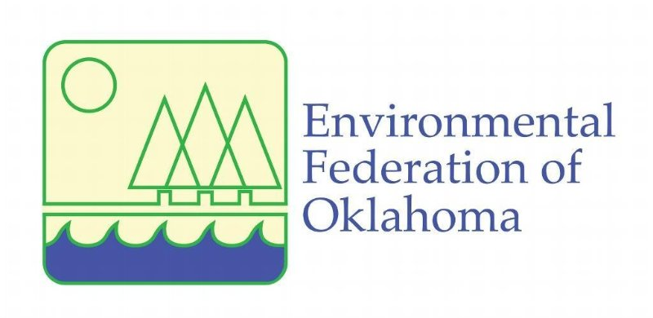

***“ Working for Oklahoma’s Economic and’s Economic and Environmental Future”***

**For more information contact:**

**Howard L (Bud) Ground, President**

**Environmental Federation of Oklahoma**

**4 N.E. 10th Street #443**

**Oklahoma City, OK 73104**

**Office 405.942.2334**

[**efo@envirofdok.org**](mailto:efo@envirofdok.org)

[**www.envirofdok.org/membership**](http://www.envirofdok.org/membership)

**University Membership**

Oklahoma Universities offering degrees in environmental, health, and safety fields and/or associated fields may join EFO as Associate member. This allows you to connect with Oklahoma industries who will be hiring your students as their employees. It also allows you to keep in touch with the real world of EHS management with all of its regulatory and legal aspects. University personnel also get the government employee rate to attend EFO events – a significant reduction in price!

**Student Membership**

Beginning in the Fall 2019, EFO is offering a Student Membership available to students enrolled in an Oklahoma university interested in a career in environmental, health, and safety and associated fields (e.g., law, engineering, etc.). Membership term is September through the following August.

Benefits of both University and Student Membership include:

* Significantly reduced pricing for event attendance
* Receive the weekly ***EFO News Update***
* Website access

**Membership Fees**

* Associate $600
* Student $15

Call to discuss appropriate membership level for your company. All applications subject to review and approval.

**Mission Statement**

* Actively promoting the development of sound environmental policies and legislation
* Educating and informing EFO members, government officials and the citizens of Oklahoma as to the environmental issues affecting commerce
* Addressing the common environmental concerns of EFO members

**Membership Benefits**

* Legislative lobbying for Oklahoma businesses with weekly updates on pending legislation and other regulatory news
* Regulatory interface between business and the regulatory agencies
* Outreach to other business interest groups
* ***Members ONLY***Weekly ***EFO News Update*** to keep you current on regulatory news
* Access to **Members ONLY** part of website
* Reduced rates to attend events
* Dues are typically 50% tax deductible
* Eligible for ***Frank Condon Environmental Excellence Award*** for environmental projects (not available to students)

**Activities**

* Legislative Reception – exclusive for ***Members ONLY***
* ***EFO Newsreel*** – co-sponsored with the ODEQ in June annually
* ***EFO Annual Meeting and Trade Show*** held annually each fall
* Other technical seminars as regulations are issued or updated